Table of Contents

1. Feature Overview 2

1.1 Feature Description 2

2. Use Case: Capture Quantity 2

2.1 Feature Flow 2

2.2 Preconditions 2

2.3 Main Flow 2

3. Supplemental Specifications 2

3.1 Layaway Deposit Feature 2

3.2 Modify Item Feature 2

3.3 Pre-Order Feature 2

3.4 Sale Feature 2

4. Screen Layouts 3

4.1 Capture Quantity Prompt 3

4.2 Message Prompts 4

5. Printing 4

5.1 Receipt Changes 4

6. Configurable Settings 4

7. Logging Changes 4

7.1 Data Output 4

8. Interface Changes 4

9. Business Sign Off 4

10. Revision History 5

10.1 Reviews 5

10.2 Revision History 5

Feature Overview

## Feature Description

The Quantity Feature document defines the process of capturing quantity amount for an item along with screen mockups.

# Use Case: Capture Quantity

## Feature Flow



Figure : Quantity Flow

## Preconditions

* User has completed action requiring capturing of quantity amount.

## Main Flow

1. System prompts for quantity (section 4.1).
2. If User selects back the system returns to calling use case.
3. If User enters invalid amount (less than 0 or greater than max quantity allowed for item) and selects continue, System displays Invalid Quantity Prompt (section 4.2.1) and restarts main flow.
4. If User enters valid quantity and selects continue, System updates and displays item quantity, use case ends and system returns to the calling use case.

## Special Requirements

1. Items with quantity are not eligible for deals.

# Supplemental Specifications

## Layaway Deposit Feature

Layaway Deposit Use Case is updated to capture quantity for quantity required items.

## Modify Item Feature

Modify Item Use Case is updated to capture quantity for Quantity Override Feature.

## Pre-Order Feature

Pre-Order Use Case is updated to capture quantity for quantity required items.

## Sale Feature

Sale Use Case is updated to capture quantity for quantity required items.

# Screen Layouts

## Capture Quantity Prompt

This is displayed when quantity for an item is needed and prompts the user to enter the item quantity.

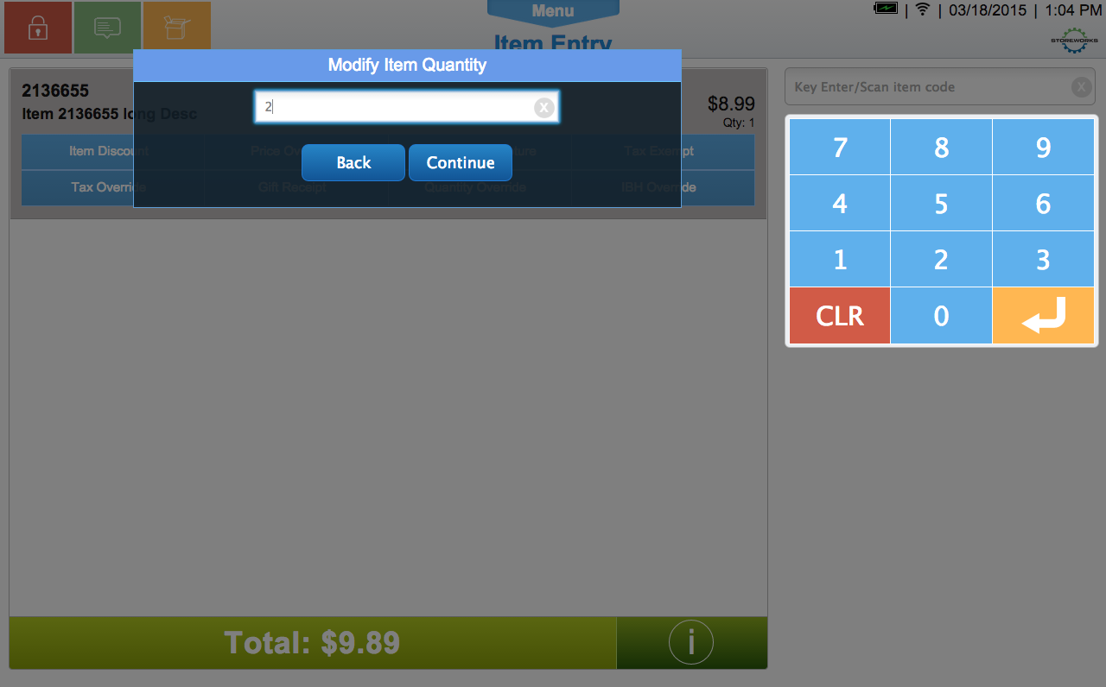

Figure : Quantity Capture Prompt

#### Screen Definitions

##### Prompt Title Text

|  |
| --- |
| **Text is Configurable** |
| Modify Item Quantity |

##### Instruction Text

|  |
| --- |
| **Instruction Text in Input Box– Text is Configurable** |
| Enter Item Quantity |

##### Navigation/Menu Keys

| **Key** | **Label** | **State** | **Next Screen** | **Notes** |
| --- | --- | --- | --- | --- |
| Back | Back | Enabled | * Calling Use Case | Text is configurable |
| Continue | Continue | * Disabled if no amount entered * Enabled if amount entered. | * Sale Use Case | Text is configurable |

##### Data/Input Field Enhancements

|  |  |  |  |  |  |  |
| --- | --- | --- | --- | --- | --- | --- |
| **Label** | **Editable** | **Req’d?** | **Data Type** | **Min**  **Length** | **Max**  **Length** | **Notes** |
| Quantity Amount | Yes | Yes | Numeric | 1 | 9999 | Includes indicator on right to clear box. |

## Message Prompts

### Invalid Quantity Prompt

|  |  |
| --- | --- |
| **Description** | Message displays when quantity entered is not valid |
| **Message** | Invalid Quantity |
| **Key prompt** | OK – continues returns Quantity Prompt. |
| **Notes** | * Text for the message is configurable. * If no text defined, system displays a default message. * Key prompt text is configurable |

# Printing

## Receipt Changes

### Quantity Item

The quantity for the item prints directly below the item long description as shown in **blue** below.

…

10001000 Item Desc 19.98

Item long description

**2 @ 9.99**

…

# Configurable Settings

No Configurable Settings defined.

# Logging Changes

## Data Output

|  |  |  |
| --- | --- | --- |
| **Data Element** | **Description** | **Destination** |
| Quantity | Item Quantity | * Dirty Electronic Journal * POSLog |

# Interface Changes

No Interfaces for this feataure.

# Business Sign Off

|  |  |  |
| --- | --- | --- |
| **Name** | **Organization** | **Approval Email and/or Date Received** |
|  |  |  |

# Revision History

## Reviews

|  |  |  |
| --- | --- | --- |
| **Date** | **Iteration** | **Result** |
|  |  |  |

## Revision History

|  |  |  |  |
| --- | --- | --- | --- |
| **Reviser** | **Revision** | **Date** | **Version** |
| Amy Byers | Initial document | 3/19/2015 | 1.0 |